Dashboard Design
Name | Manpreet Kaur
Date | 19 July 2026
Project Name | Food Ordering Behaviour and Consumer Trends: A Structured Analysis of Choices and Habits

Activity 1: Interactive and visually appealing dashboards
Two interactive dashboards were designed following core dashboard-design principles: a clear and intuitive layout, appropriate chart types per question, consistent colour theming, interactive filters, drill-down capability, and responsive layout.
DASHBOARD 1:
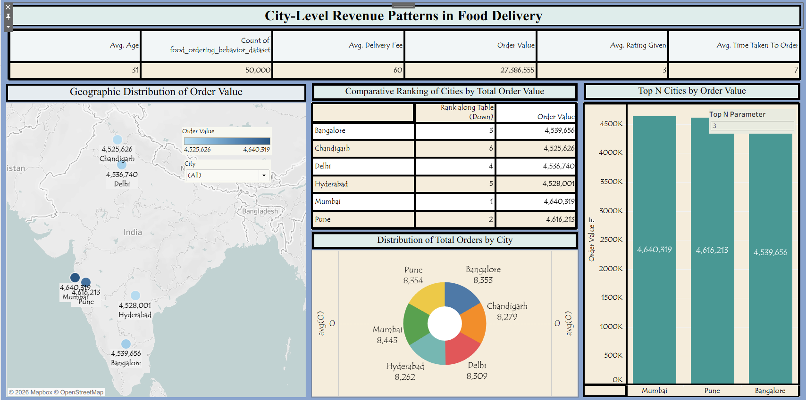

Dashboard 1: City-Level Revenue Patterns in Food Delivery
- Dataset Overview: The analysis covers 50,000 food ordering records, with an average customer age of 31, an average delivery fee of ₹60, total order value of ₹27,386,555, an average rating of 3, and an average order time of 7 minutes.
- Top Revenue City: Mumbai leads in total order value at ₹4,640,319, followed closely by Pune (₹4,616,213) and Bangalore (₹4,539,656).
- Narrow Revenue Spread: Order values across all six cities are tightly clustered between ₹4.52M–₹4.64M, indicating fairly even demand distribution rather than one dominant market.
- Order Volume Leaders: Mumbai also tops order count (8,443), while Hyderabad has the lowest volume (8,262) — though the gap across cities is minor (~180 orders).
- Bottom Performer: Chandigarh ranks last in both total order value (₹4,525,626) and is ranked 6th overall, suggesting it may need targeted promotions or delivery incentives.
Activity 2
Publish Dashboard on Tableau Public and Paste the Dashboard Public link below:
https://public.tableau.com/app/profile/manpreet.kaur7362/viz/City-LevelRevenuePatternsinFoodDelivery/Dashboard1?publish=yes
DASHBOARD 2:
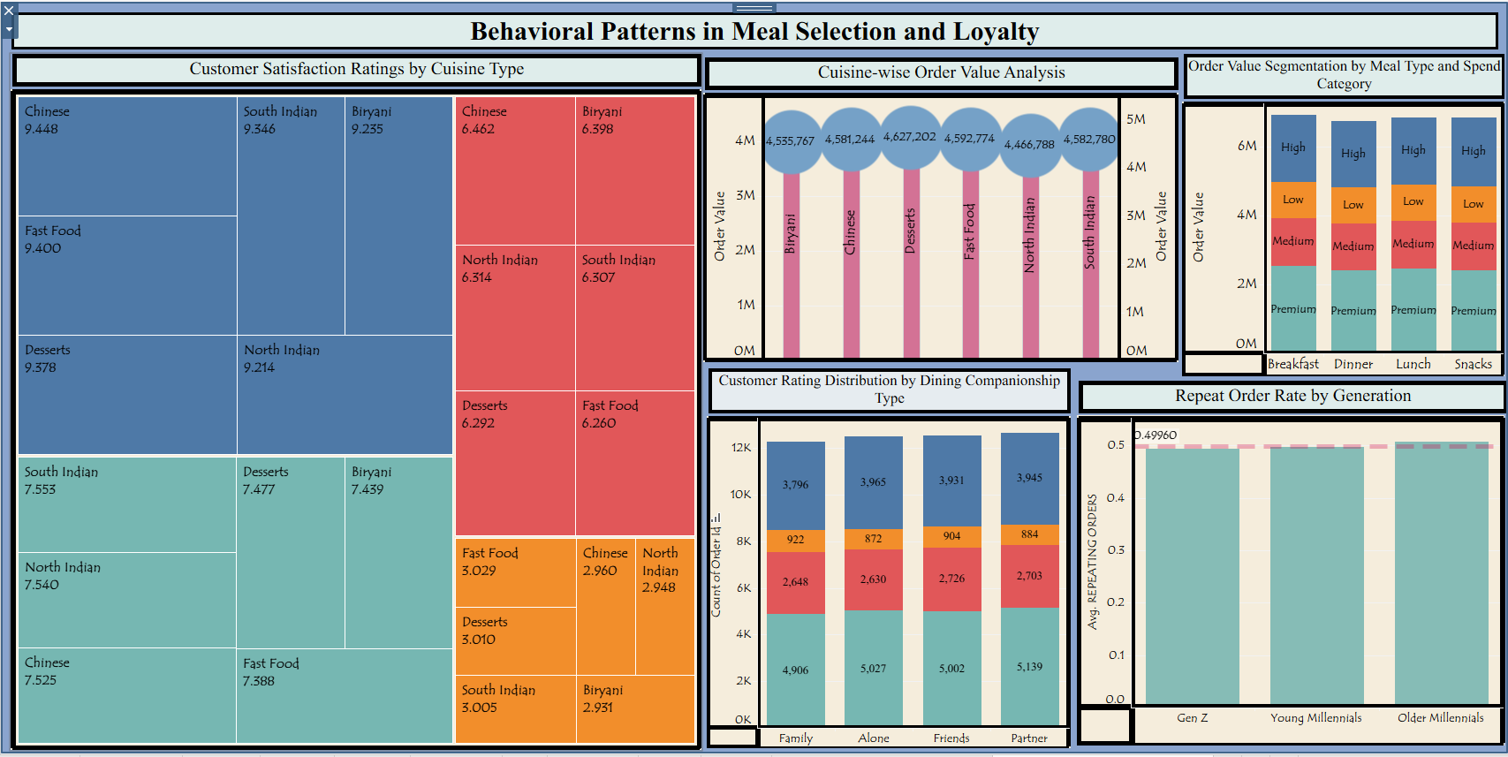

Dashboard 2: Behavioral Patterns in Meal Selection and Loyalty
- Cuisine Satisfaction: South Indian and Chinese cuisines receive the highest satisfaction scores (~9.5 range), while ratings vary more broadly across other cuisine-metric combinations (roughly 7.2–9.5), pointing to inconsistent experience quality by cuisine.
- Highest-Value Cuisine: Desserts generate the highest average order value (₹4,627,202), followed by South Indian (₹4,582,780) and Fast Food (₹4,592,774), while North Indian trails at ₹4,466,788.
- Spend Segmentation: Order value splits fairly evenly across Breakfast, Lunch, Dinner, and Snacks when broken into High/Medium/Low/Premium spend tiers — no single meal occasion dominates revenue.
- Dining Companionship Patterns: Orders placed "Alone" and with "Family" show the highest order counts (~12K each), suggesting solo and family dining are the primary consumption occasions.
- Loyalty by Generation: Repeat order rate hovers close to the 0.4996 average across Gen Z, Young Millennials, and Older Millennials — indicating loyalty behavior is fairly consistent across generational segments rather than concentrated in one group.

Activity 2
Publish Dashboard on Tableau Public and Paste the Dashboard Public link below:
https://public.tableau.com/app/profile/manpreet.kaur7362/viz/BehavioralPatternsinMealSelectionandLoyalty/BehavioralPatternsinMealSelectionandLoyalty?publish=yes

